Tradeoff Matrix Write Up

For the prototype of the detection system the sensors should have a range of at least 75 feet, a small field of view, and a reasonable sample rate. The small field of view allows each sensor to be treated close to a ‘pixel’ of detection, the smaller the field of view, the more accurate the estimation can be. The decent range of 75 feet allows the geometry of angles of the sensors to spread out enough for full scale (i.e. human or vehicle) tests. The sample rate of the device determines how fast the test objects can move, a full scale vehicle test would require a high refresh rate for a camera, but a low sampling rate for an IR sensor (30 – 60 fps performs well on most vehicle speeds according to simulation).

Four sensors were considered for this project. The first sensor considered was a simple passive infrared sensor, which would be connected through an ADC or GPIO to the Raspberry Pi. The second was an off the shelf IR security sensor which would interface similarly to the Pi. The third option is a standard web camera with a USB connection to the processor. The final option was the FLIR Lepton infrared camera. This option interfaces to the Pi in one of two ways: SPI data and I2C command line or over USB like a webcam with a breakout board.

A standard PIR sensor has a range of up to 20 feet and a wide field of view. This can be narrowed by using lenses, the smallest of which produced a 10 degree FOV. The signal out of a PIR sensor would need to be sampled by an ADC to analyze the waveform of the sensor. Circuits also exist to simply raise a GPIO pin if an intrusion is detected, but these do not provide enough data for this project as they only provide one bit of resolution. The power consumption of these sensors can be relatively low, and they are easily extended to an array of four with a multi-channel ADC or multiple GPIOs. Price is another strong point for this type of sensor as they are very cheap. Unfortunately for this prototype the PIR sensor’s range and wide FOV make them nearly unusable. Ultimately in order to create a low power solution Sandia will look into creating a custom lens system to implement this project, however the lens design is beyond the scope of this project and paying for such a device is beyond the budget.

PIR Sensor wave forms

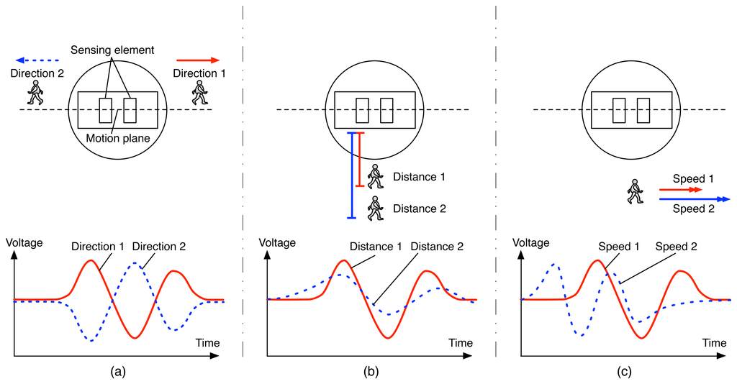

<http://www.mdpi.com/sensors/sensors-14-08057/article_deploy/html/images/sensors-14-08057f2-1024.png>

The Takex PIR-50NE is an off the shelf security solution with a PIR sensor at its core that solves the FOV and range problems of the standard PIR sensor. With a 165 foot range and 3.5 degree FOV this sensor has great range and narrow spread. The weaknesses of this sensor come from implementation complexity, power consumption, and cost. All TAKEX sensors are produced ready to be integrated into existing security systems meaning the device would need to be opened and modified to give the Raspberry Pi direct access to the waveform from the PIR sensor at its core. In the out of the box state, the sensor sends a 20V 100 mA pulse for 2 seconds upon an intrusion detection, a sampling rate that is much too low and a power consumption that is much too high. With an individual cost of $520 this sensor is also the most expensive of the four. The TAKEX PIR-50NE contains a sensor and lens system that is nearly ideal for this project, however the price and unknown complexity of modifying the sensor hurt its viability.

The third option was using a basic web camera as the sensor. This option provides flexibility in FOV, great range, low cost, and is easy to implement. However, these cameras simply don’t monitor the radiation this project is interested in. A different image processing project could be completed using web cameras, but for this project an IR sensor is necessary.

The final and chosen option is the FLIR Lepton v3 IR Cameras. This camera has a 160x120 resolution which allows for flexible FOV settings, a good range of 100 feet, medium cost, and low power consumption. The PureThermal 1 breakout board changes the interface from SPI video and I2C command to UVC USB video format. The weakness of this option is its 9 FPS. This sample rate is very low; however a solution is slowing the test objects. The Raspberry Pi has 4 USB ports, so four cameras can be attached to four independent ports (and a mouse and keyboard with a powered hub). Thus through the Linux interface v4l2 (video for Linux 2) frames of data can be captured and processed in many languages (C and Python notably). Due to cost, range, and flexibility the FLIR Lepton v3 Cameras with PureThermal 1 breakout board were chosen as the sensor for this system’s prototype.